Guided Capstone Project Report - Blue Mountain Resorts

**Recap:**

Big Mountain Resort is large ski resort in northwestern Montana. BMR has recently installed a new chair lift to help increase the distribution of visitors across the mountain. This investment will increase operating costs by $1.54MM this season and management is looking for ways to recoup this cost without harming the current profit margin.

**Method/Models:**

We compare features of BMR to competing resorts in order to see if we can improve our pricing strategy to increase revenue. After cleaning and scaling the features, we created 3 clusters to group similar resorts. Once adding the clusters back as an additional feature, we create a linear regression model to help us find the appropriate price for an adult weekend ticket.

**Results:**

Correlation heatmap of features:

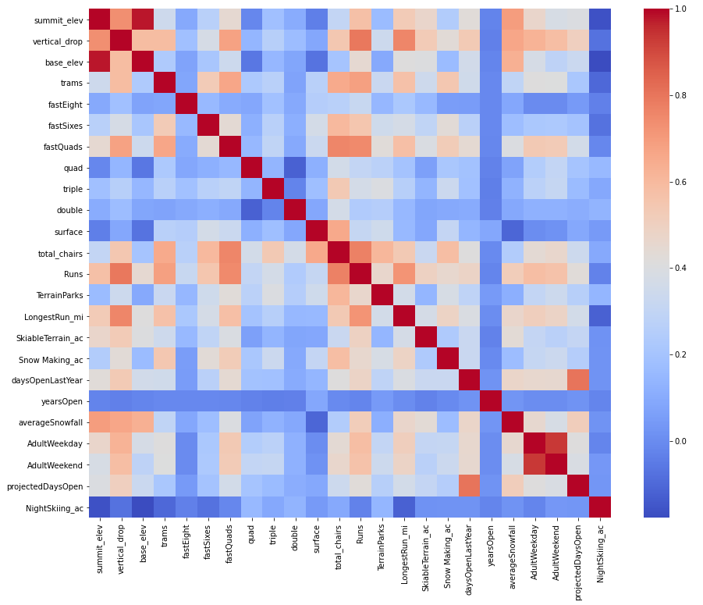

Our fit model had the below results on the out of sample data:

*Explained Variance: 0.9322*

*MAE: 5.187*

*Top Features:*

|  |  |
| --- | --- |
| **Feature** | **Coefficient** |
| **Cluster 0** | 18.833490 |
| **fastSixes** | 1.863121 |
| **summit_elev** | 1.681521 |
| **SkiableTerrain_ac** | 1.565536 |
| **surface** | 1.460822 |
| **NightSkiing_ac** | 1.402364 |
| **total_chairs** | 1.358201 |
| **vertical_drop** | 1.323196 |
| **TerrainParks** | 1.215341 |
| **AdultWeekday** | 0.957502 |

Looking at the regression for some of the most important features below, it seems that BMR could be charging more for the adult weekend tickets.

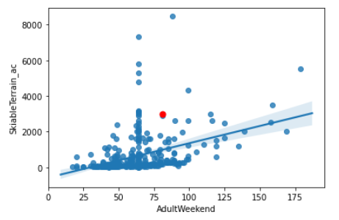

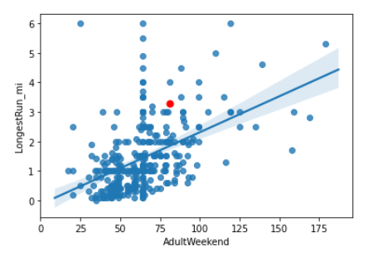

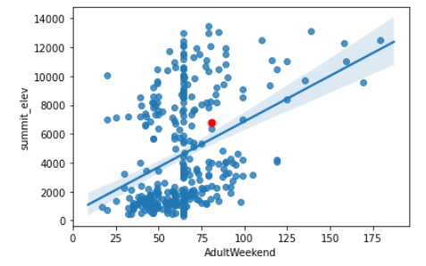

In fact, according to our model, the appropriate price to charge would be **$88.43** vs. the current price of **$81.00**

This price increase should significantly improve revenue for BMR and put them well on their way of making up for their increased operating costs.